Chapter 7: The Great Migration
and Push for Democracy
The Great Migration

- What does migration mean?
_____________________________________________
- What was the Great Migration?
_______________________________________________________________________________________________________________________________________
- What triggered (started/caused) the Great Migration?
Poverty in Britain Opportunities in the Colonies
____________________ __________________________
____________________ __________________________
____________________ __________________________
____________________ __________________________
4. What impacts did the Great Migration have on:
First Nations _________________________________________________________________________________________________________________________________________________________________________________________________________
Canadiens _________________________________________________________________________________________________________________________________________________________________________________________________________

Bonus: What is Grosse Ile? What is Grosse Ile important in Canadian History? ___________________________________________________________________________________________________________________________
Grosse Ile

The Push for Democracy
- What is a democracy? _____________________________________________

Thoughts and Problems with Democracy
I believe everyone should be treated equal!

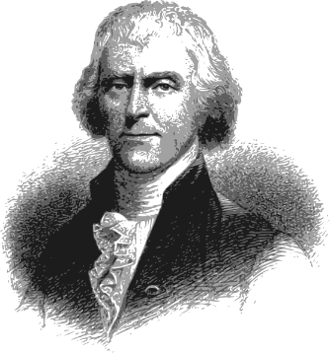
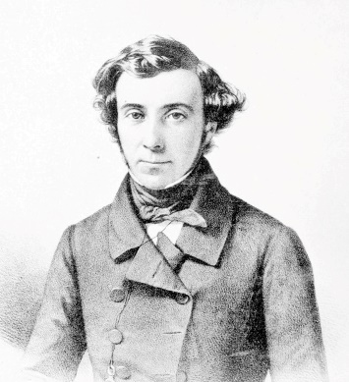
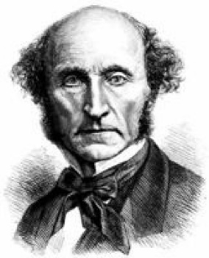
Who is pictured to the left? Do you agree with his statement? Why?
Should everyone be able to vote? What if people are idiots and vote poorly?
I am concerned about minority rights!
________________________________________________ ________________________________________________ ________________________________________________ ________________________________________________

Who is pictured to the left? What is the tyranny of the majority?
______________________________________________ ______________________________________________ ______________________________________________ ______________________________________________

Who is pictured to the left? Do you think we can trust voters to stay informed? Should our “everyone gets a vote” system be changed in your opinion? Why? ______________________________________________ ______________________________________________ ______________________________________________ ______________________________________________

What did the Reformers want?
The Reformers
With new ideas about democracy surfacing, who were the reformers? What did each Canadian reformer want to change about the current British-led government?
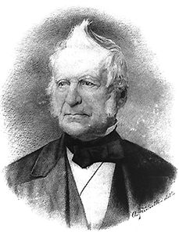

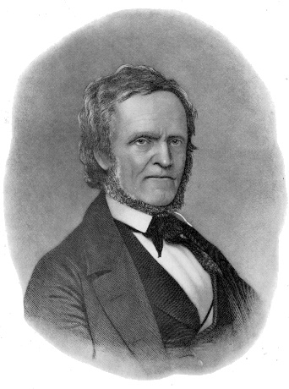
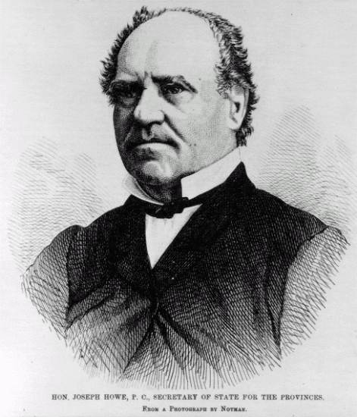

The Rebellions of 1837 & 1838

What were the key events which sparked rebellion in Upper Canada?
1.

2.

3.

4.

What were the key events which sparked rebellion in Lower Canada?
1.

2.

3.

4.

5.

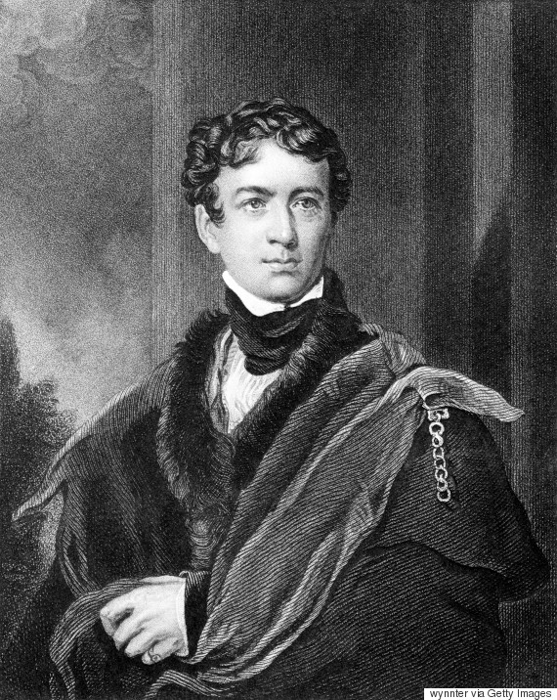
Britain Sends Lord “Radical Jack” Durham to find a solution!
Britain’s Response to the Rebellions

After visiting British North America, Lord Durham writes several recommendations to Britain about ways to resolve the issues of rebellion.

What three recommendations does Lord Durham give in the famous Durham Report?

- _________________________________________________________
- _________________________________________________________
- _________________________________________________________

How did the Durham Report shape Canada the way we know it today?
__________________________________________________________________________________________________________________________________________________________________________________________

